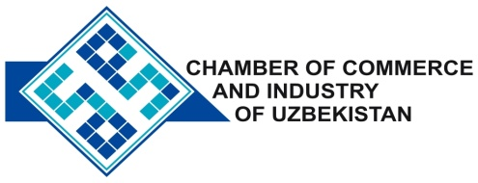

**Commercial offer of Uzbek Products to Foreign Buyer**

Dear Sirs, KP - 029

We offer quotation of the Uzbek joint venture company Ltd « ZHOMBOY ZHAVOHIRI»

**Information about the company:**

The Company “ZHOMBOY ZHAVOHIRI” was founded in 2010. The company specializes in the production micro calcite.

**List of products:**

Micro calcite

**Benefits:**

The company's goal - to provide our customers quality products for more than 20 species.

**Terms of delivery:** FCA Tashkent

If you are interested, we are happy to provide additional information in accordance with your request.

E-mail: [export@chamber.uz](mailto:export@chamber.uz)

Website: [www.chamber.uz](http://www.chamber.uz)

Export Promotion Department.

Chamber of Commerce of the Republic of Uzbekistan.